Hylonomus ✝︎
Common name: Early reptile
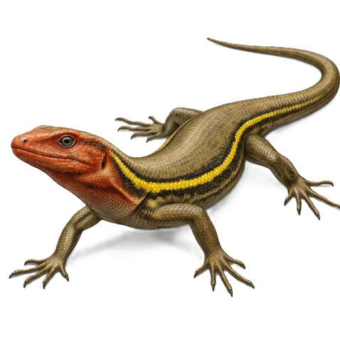
Hylonomus is one of the earliest known reptiles.
It lived during the Carboniferous period.
Shows early adaptation to terrestrial life.
Introduction
Hylonomus lived about 315 million years ago.
Fossils were found in North America.
It represents early amniote evolution.
General features
Level of Organisation: Organ system level
Germ layer: Triploblastic
Body symmetry: Bilateral
Coelom: True coelom
Body plan: Tube within a tube body plan (Deuterostomous)
Digestion type: Complete
Respiratory type: Pulmonary respiration
Circulatory type: Closed, double, incomplete double
Circulation system: Closed
Regulation of Osmosis: Osmoregulator
Excretory organ: Kidneys
Mode of excretion: Uricotelism
Skeleton structure: Endoskeleton
Nervous system: Moderately developed
Metamerism: Absent
Fertilization: Internal
Development type: Direct (oviparous)
Body temperature: Poikilothermic
Taxonomy path
Kingdom: Animalia
Phylum: Chordata
Class: Reptilia
Order: Captorhinida
Family: Captorhinidae
Genus: Hylonomus
Species: —
Structure and looks
• Small lizard-like body
• Slender limbs
• Long tail
• Sharp teeth
Ecological role
• Insect predator
• Early terrestrial vertebrate
• Forest floor inhabitant
Economical role
• Important fossil in reptile evolution
• Helps trace origin of amniotes
• Paleontological significance

Climatius ✝︎
Common name: Spiny shark (primitive fish)
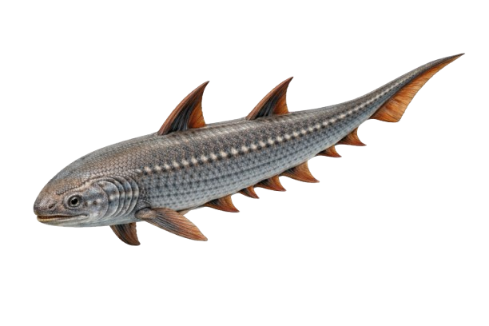
Climatius was an early jawed fish.
Belonged to Acanthodii group.
Had multiple fin spines.
Introduction
Lived during the Devonian period.
Fossils found in Europe.
Represents early jawed vertebrates.
General features
Level of Organisation: Organ system level
Germ layer: Triploblastic
Body symmetry: Bilateral
Coelom: True coelom
Body plan: Tube within a tube body plan (Deuterostomous)
Digestion type: Complete
Respiratory type: Branchial respiration
Circulatory type: Closed, single
Circulation system: Closed
Regulation of Osmosis: Osmoregulator
Excretory organ: Kidneys
Mode of excretion: Ammonotelism
Skeleton structure: Cartilaginous endoskeleton
Nervous system: Well developed
Metamerism: Present
Fertilization: External
Development type: Indirect
Body temperature: Poikilothermic
Taxonomy path
Kingdom: Animalia
Phylum: Chordata
Class: Acanthodii
Order: Climatiiformes
Family: Climatiidae
Genus: Climatius
Species: —
Structure and looks
• Streamlined body
• Multiple fin spines
• Small size
• Shark-like appearance
Ecological role
• Small aquatic predator
• Early jawed fish radiation
• Freshwater ecosystem member
Economical role
• Fossil evidence of fish evolution
• Study of jaw development
• Paleontological importance

Cephalaspis ✝︎
Common name: Armored jawless fish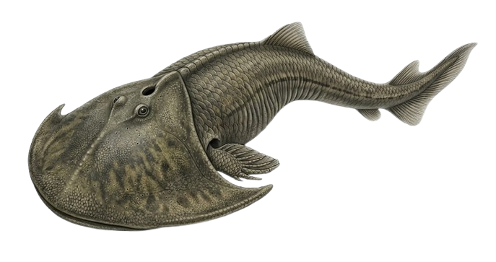

Cephalaspis was a jawless armored fish.
Belonged to Ostracodermi.
Had bony head shield.
Introduction
Lived during the Devonian period.
Fossils found in Europe and North America.
Represents early vertebrate evolution.
General features
Level of Organisation: Organ system level
Germ layer: Triploblastic
Body symmetry: Bilateral
Coelom: True coelom
Body plan: Tube within a tube body plan (Deuterostomous)
Digestion type: Complete
Respiratory type: Branchial respiration
Circulatory type: Closed, single
Circulation system: Closed
Regulation of Osmosis: Osmoregulator
Excretory organ: Kidneys
Mode of excretion: Ammonotelism
Skeleton structure: Bony exoskeletal plates
Nervous system: Primitive vertebrate type
Metamerism: Present
Fertilization: External
Development type: Indirect
Body temperature: Poikilothermic
Taxonomy path
Kingdom: Animalia
Phylum: Chordata
Class: Ostracodermi
Order: Cephalaspidiformes
Family: Cephalaspididae
Genus: Cephalaspis
Species: —
Structure and looks
• Broad armored head
• Jawless mouth
• Flattened body
• Tail fin present
Ecological role
• Bottom feeder
• Early vertebrate lineage
• Freshwater inhabitant
Economical role
• Important fossil fish
• Evidence for vertebrate evolution
• Paleo-studies

Diomedea
Common name: Albatross
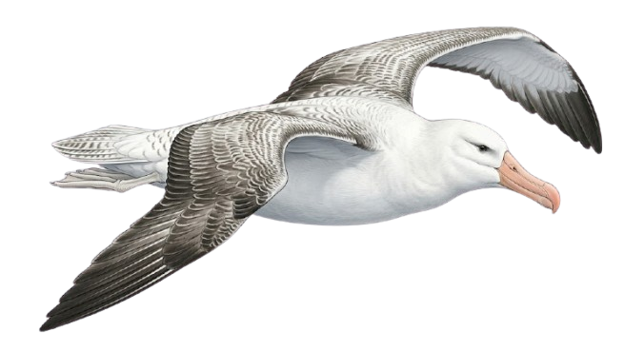
Albatross is a large seabird.
Has very long wings.
Excellent glider.
Introduction
Found in southern oceans.
Feeds on fish and squid.
Known for long-distance flight.
General features
Level of Organisation: Organ system level
Germ layer: Triploblastic
Body symmetry: Bilateral
Coelom: True coelom
Body plan: Tube within a tube body plan (Deuterostomous)
Digestion type: Complete
Respiratory type: Pulmonary respiration with air sacs
Circulatory type: Closed, double, complete
Circulation system: Closed
Regulation of Osmosis: Osmoregulator
Excretory organ: Kidneys
Mode of excretion: Uricotelism
Skeleton structure: Endoskeleton
Nervous system: Well developed
Metamerism: Absent
Fertilization: Internal
Development type: Direct (oviparous)
Body temperature: Homeothermic
Taxonomy path
Kingdom: Animalia
Phylum: Chordata
Class: Aves
Order: Procellariiformes
Family: Diomedeidae
Genus: Diomedea
Species: —
Structure and looks
• Very large wingspan
• White and black plumage
• Hooked beak
• Webbed feet
Ecological role
• Marine predator
• Ocean ecosystem balance
• Long-distance migratory bird
Economical role
• Ecotourism
• Marine studies
• Conservation programs

Raphus cucullatus ✝︎
Common name: Dodo
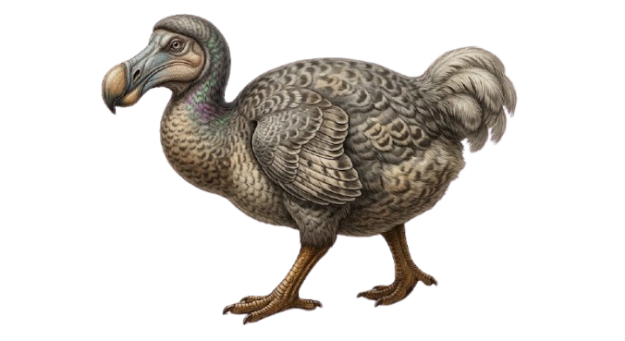
Raphus cucullatus was a flightless bird.
Endemic to Mauritius.
Extinct due to human activity.
Introduction
Lived until the 17th century.
Inhabited island forests.
Example of human-caused extinction.
General features
Level of Organisation: Organ system level
Germ layer: Triploblastic
Body symmetry: Bilateral
Coelom: True coelom
Body plan: Tube within a tube body plan (Deuterostomous)
Digestion type: Complete
Respiratory type: Pulmonary respiration with air sacs
Circulatory type: Closed, double, complete
Circulation system: Closed
Regulation of Osmosis: Osmoregulator
Excretory organ: Kidneys
Mode of excretion: Uricotelism
Skeleton structure: Endoskeleton
Nervous system: Well developed
Metamerism: Absent
Fertilization: Internal
Development type: Direct (oviparous)
Body temperature: Homeothermic
Taxonomy path
Kingdom: Animalia
Phylum: Chordata
Class: Aves
Order: Columbiformes
Family: Columbidae
Genus: Raphus
Species: Raphus cucullatus
Structure and looks
• Large round body
• Small wings
• Strong legs
• Curved beak
Ecological role
• Island seed disperser
• Ground-dwelling bird
• Example of island evolution
Economical role
• Symbol of extinction
• Conservation awareness
• Evolutionary research

